SMPL: Harvest Sampling Calculations
Test Script

Template Version Number: 1.0

Document Approval / Review (To be completed pre-execution of Tests)
 | Name & Role | Signature | Date
Author | Carlos Redekopp (Developer) | CR | 06-15-2026
Reviewed | Thomas Rautenbach | Thomas Rautenbach | 18JUN1016
Approved
Approved

Version Control
Version | Date | Description of Changes | Author
1.0 | 06-15-2026 | Initial unit test script for SMPL: Harvest Sampling Calculations | Carlos R

Referenced Documents
No. | Document Title and ID | Version | Location
1 | SMPL: Harvest Sampling Calculations XStep Design Specification | 1.0 | Project documentation / controlled repository
2 | SMPL: Two Variable Calc XStep Design Specification |  | Project documentation / controlled repository
3 | SiMPL Functional Guide: Universal Concepts |  | Project documentation / controlled repository

Disclaimer
If you are reading a copy of this document (i.e. print out of controlled electronic document or an electronic copy of a wet ink signed paper document) you may be reading an uncontrolled version. Before making updates, please ensure that you are using the latest version of this document and the associated template.

Test Script ID & Version #: | HLOG-UT-001 / V1.0 | Test Phase: | Unit Test
Test Name: | SMPL: Harvest Sampling Calculations
Test Objective: | To verify that the SMPL: Harvest Sampling Calculations XStep displays the configured MBR text and labels, captures DLIMS project and sample identifiers, performs two sequentially linked calculations using /SMPL/PPPI_FM_CALC_VALIDATE, passes the first calculation result into the second calculation, and supports the configured electronic signatures.
Requirements Tested: | The test covers IV_HEADER, IV_INSTR, IV_LABEL1, IV_LABEL2, IV_SIGN, IV_TAB_TIT1, IV_TAB_TIT2, IV_TITLE1 through IV_TITLE4, IV_RES_TIT1, IV_RES_TIT2, IV_VAL1, IV_VAL2, IV_VAL3, IV_TYPE1, IV_TYPE2, IV_RESULT1, IV_RESULT2, numeric-entry validation, and Performed By/Witnessed By signature behavior.

Pre-requisites:
• A released SAP process order exists with SMPL: Harvest Log assigned through the relevant SiMPL Master Recipe.
• The test user has access to the SiMPL EBR/Fiori application and the required plant authorization.
• The MBR parameters for header text, instructions, metadata labels, table titles, column labels, result labels, constant value, and operation signs are configured.
• /SMPL/PPPI_FM_CALC_VALIDATE is available and active for both calculation blocks.
• Approved operator and verifier accounts are available for the configured electronic signatures.
Set Up Steps: | Data Requirements:
• Create or identify the released process order.  • Open the EBR and confirm the XStep is visible in the applicable phase.  • Confirm the active MBR values for IV_VAL2, IV_TYPE1, and IV_TYPE2.  • Independently calculate the expected IV_RESULT1 and IV_RESULT2 values for the planned test inputs.  • Confirm the configured Performed By and Witnessed By signature requirements. | • DLIMS Project Number test value.  • DLIMS Sample Number test value.  • Valid Protein Concentration Result input.  • Valid Volume input.  • Active Table 1 constant and operation signs from the MBR.  • Expected IV_RESULT1 and IV_RESULT2 values.  • Invalid non-numeric test values.  • Valid operator and verifier credentials.

System Name & Version #: | DE1 | All pre-requisites satisfied/set up steps completed? |  | Yes / No
Environment: | DE1
Tester Name: | Carlos Redekopp | Date Test Commenced: | 06-15-2026 | Run # | 1

Instructions for the Tester:
- Carry out the action described in each step and compare the results achieved with the Expected Result to determine if the step has passed. Record the Pass / Fail status against each step.
- If the Expected Result is not met or an issue is encountered, record the related Test Issue Log (TIL) number in the Pass/Fail column against the relevant step.
- For GxP regulated systems you must document the Actual Result for the step .
- For GxP systems, wherever specifically required by the test script, documentary evidence must be collected and appropriately managed. At your own discretion you may collect additional documentary evidence to support the results achieved.

Step No. | Action / Description | Expected Result | Actual Result | Pass/ Fail  Test Issue Log #
1 | Create and release a process order containing the SMPL: Harvest Sampling Calculations XStep. | The process order is created and released successfully containing SMPL: Harvest Sampling Calculations. | The process order is created and released successfully containing SMPL: Harvest Sampling Calculations. | Pass
2 | Open the EBR for the released process order and navigate to the phase containing SMPL: Harvest Sampling Calculations. | The EBR opens successfully without errors and the SMPL: Harvest Sampling Calculations XStep is visible. | The EBR opens successfully without errors and the SMPL: Harvest Sampling Calculations XStep is visible. | Pass
3 | Verify that the IV_HEADER and IV_INSTR values configured in the SiMPL MBR appear in the XStep. | The header and instruction text display exactly as authored in the MBR. | The header and instruction text display exactly as authored in the MBR. | Pass
4 | Verify that IV_LABEL1 and IV_LABEL2 display the configured metadata field labels. | The project and sample tracking labels display according to the MBR configuration. | The project and sample tracking labels display according to the MBR configuration. | Pass
5 | Enter valid alphanumeric values in the DLIMS Project Number and DLIMS Sample Number fields. | Both metadata values are accepted and retained in the batch record. | Both metadata values are accepted and retained in the batch record. | Pass
6 | Verify that IV_TAB_TIT1 and IV_TAB_TIT2 display the configured titles for the two calculation blocks. | The two calculation sections display separate titles matching the MBR configuration. | The two calculation sections display separate titles matching the MBR configuration. | Pass
7 | Verify that IV_TITLE1 through IV_TITLE4 and IV_RES_TIT1/IV_RES_TIT2 display the configured column and result labels. | All calculation input, reference, constant, and result labels display as authored in the MBR. | All calculation input, reference, constant, and result labels display as authored in the MBR. | Pass
8 | Verify the active Table 1 constant IV_VAL2 and the configured operation signs IV_TYPE1 and IV_TYPE2. | The constant and mathematical operations match the active MBR configuration; IV_TYPE1 is division and IV_TYPE2 is multiplication unless otherwise authored. | The constant and mathematical operations match the active MBR configuration; IV_TYPE1 is division and IV_TYPE2 is multiplication unless otherwise authored. | Pass
9 | Enter a valid numeric Protein Concentration Result value in the Table 1 input field and trigger calculation. | The value is accepted and the first calculation executes using IV_VAL1, IV_VAL2, and IV_TYPE1. | The value is accepted and the first calculation executes using IV_VAL1, IV_VAL2, and IV_TYPE1. | Pass
10 | Compare the displayed Pre-Harvest Protein Concentration with the independently calculated expected result. | IV_RESULT1 is populated under IV_RES_TIT1 and matches the expected Table 1 result. | IV_RESULT1 is populated under IV_RES_TIT1 and matches the expected Table 1 result. | Pass
11 | Enter a valid numeric Volume value in the Table 2 input field and trigger calculation. | The Volume value is accepted and the second calculation executes. | The Volume value is accepted and the second calculation executes. | Pass
12 | Verify that the Harvest Protein Concentration reference in Table 2 is populated from IV_RESULT1. | The current Table 1 result is passed into Table 2 without manual re-entry. | The current Table 1 result is passed into Table 2 without manual re-entry. | Pass
13 | Compare the displayed Total Product value with the independently calculated expected result. | IV_RESULT2 is populated under IV_RES_TIT2 and matches IV_RESULT1 multiplied by IV_VAL3 using IV_TYPE2. | IV_RESULT2 is populated under IV_RES_TIT2 and matches IV_RESULT1 multiplied by IV_VAL3 using IV_TYPE2. | Pass
14 | Change the Table 1 concentration input before signing and trigger recalculation. | IV_RESULT1 recalculates and the dependent Table 2 reference and IV_RESULT2 update to reflect the revised input. | IV_RESULT1 recalculates and the dependent Table 2 reference and IV_RESULT2 update to reflect the revised input. | Pass
15 | Enter a non-numeric value in the Table 1 numeric input field. | A validation error is displayed and the Table 1 calculation is prevented. | A validation error is displayed and the Table 1 calculation is prevented. | Pass
16 | Enter a valid Table 1 value, then enter a non-numeric value in the Table 2 Volume field. | A validation error is displayed and the Table 2 calculation is prevented. | A validation error is displayed and the Table 2 calculation is prevented. | Pass
17 | Execute a configuration test where a required mathematical operation sign is not populated. | The system applies the predefined default operation or prompts for the required operation, according to configuration. | The system applies the predefined default operation or prompts for the required operation, according to configuration. | Pass
18 | Attempt to complete the Performed By signature using an incorrect username or password. | The signature is rejected and the user can re-enter valid credentials. | The signature is rejected and the user can re-enter valid credentials. | Pass
19 | Complete the Performed By signature using valid authorized operator credentials. | The electronic signature is accepted and the calculation execution is recorded. | The electronic signature is accepted and the calculation execution is recorded. | Pass
20 | Complete the Witnessed By signature using valid authorized verifier credentials. | The verifier signature is accepted and the XStep is finalized according to the configured signature profile. | The verifier signature is accepted and the XStep is finalized according to the configured signature profile. | Pass
21 | Refresh or reopen the completed XStep and review the recorded metadata, inputs, outputs, and signatures. | The completed values and signatures persist in the batch record and are locked or protected according to configuration. | The completed values and signatures persist in the batch record and are locked or protected according to configuration. | Pass

1.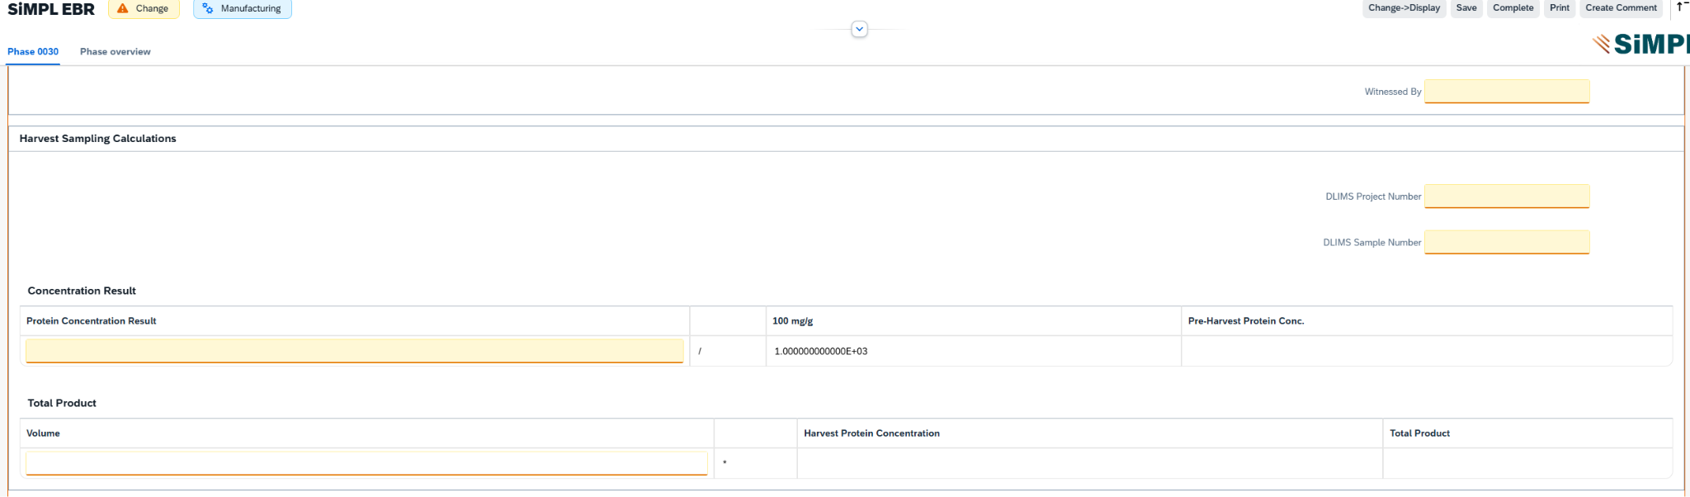
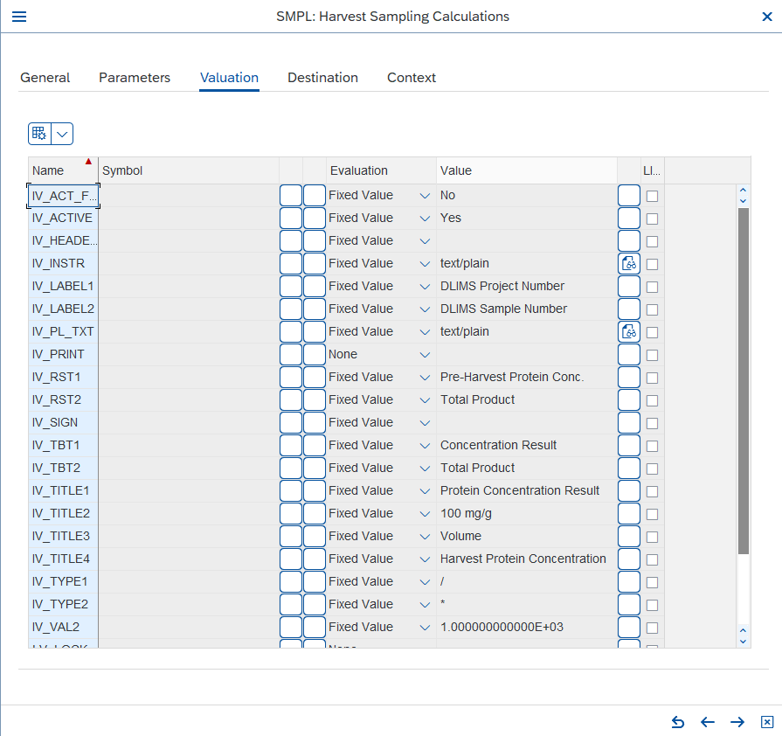
9.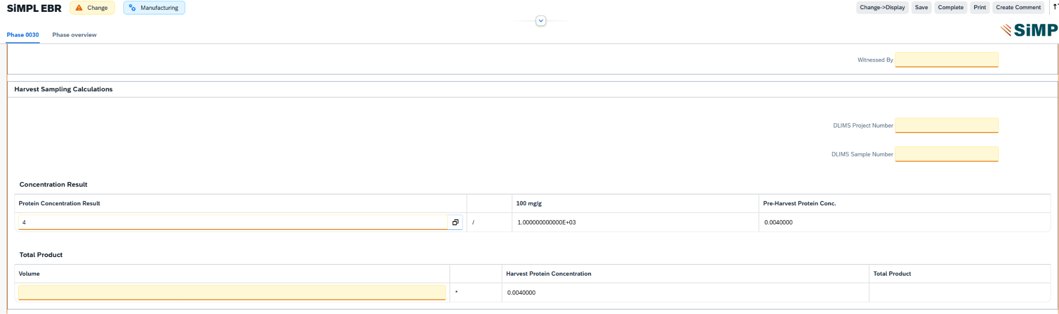
11.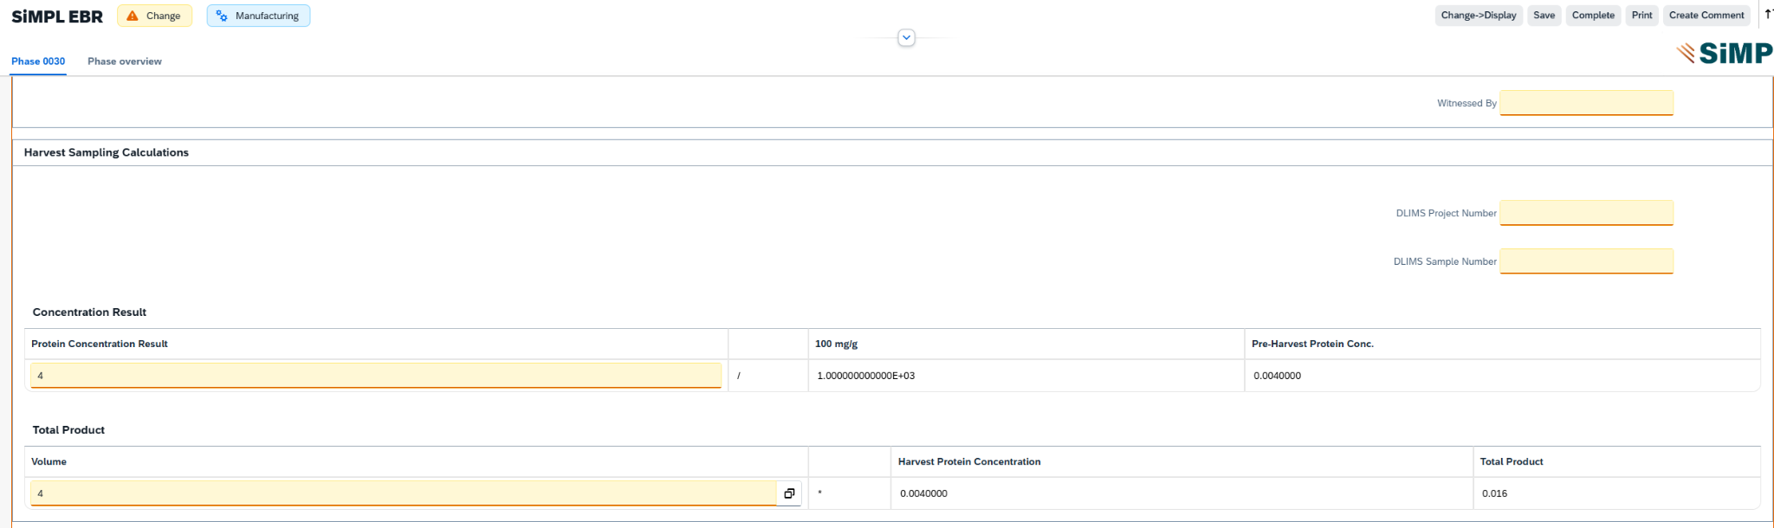
14.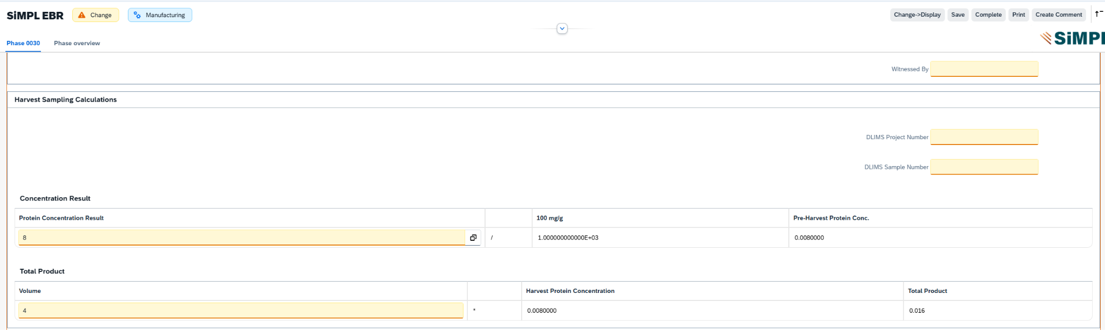
20.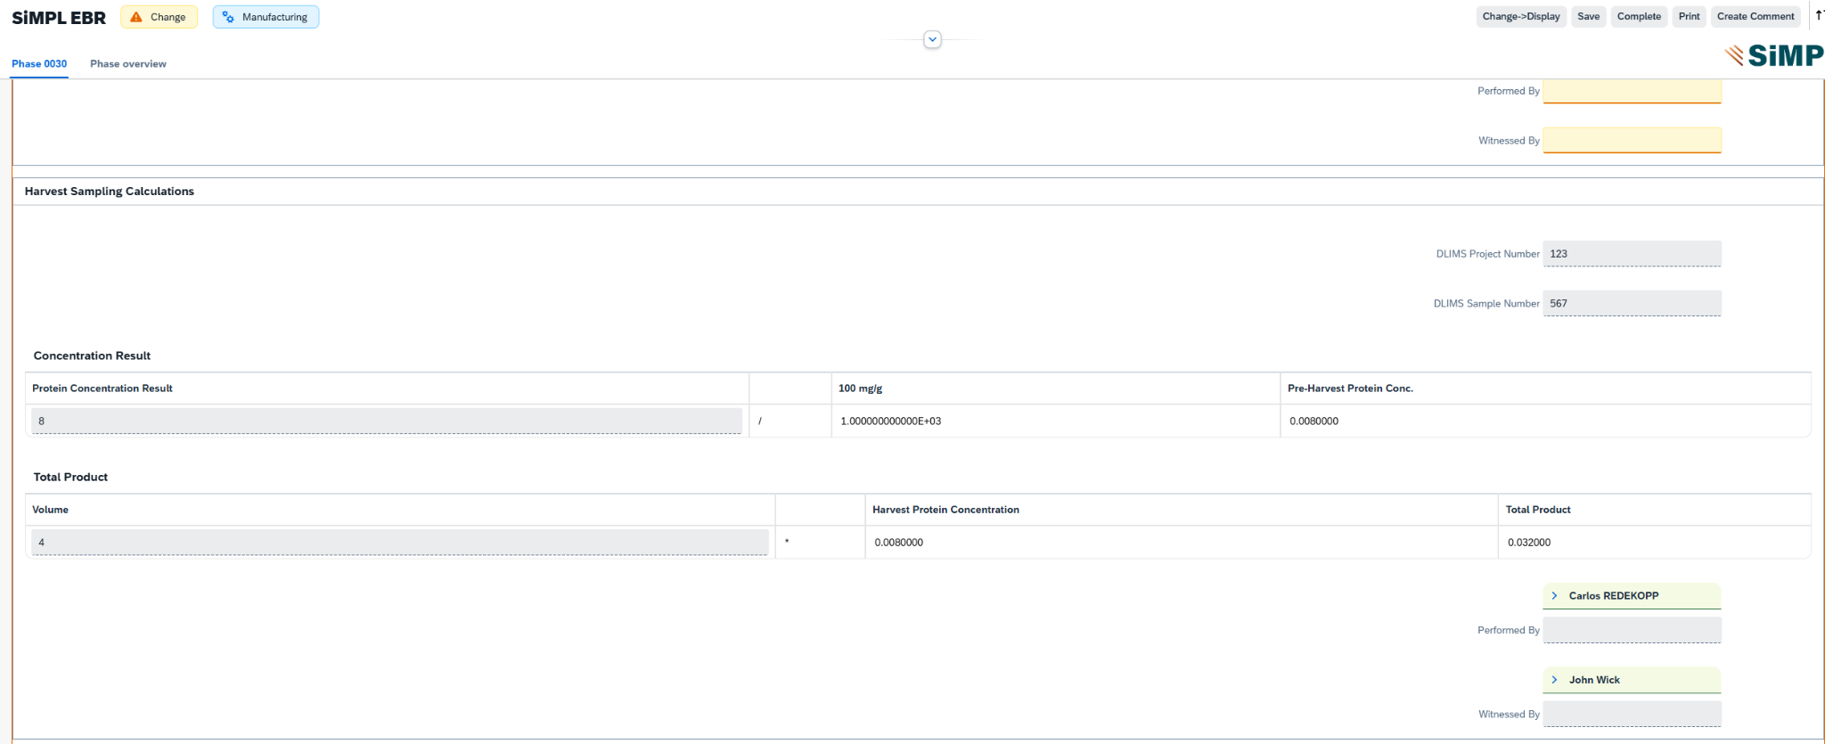

TEST SCRIPT SUMMARY RESULT
PASS/FAIL: | Pass | Comments: | All steps passed
Signature, Initials and Date Tester 1: | CR, 06-15-2026 | Printed Name  Tester 1: | Carlos Redekopp | Executed Steps | All steps
Signature, Initials and Date Tester 2 (if used): |  | Printed Name  Tester 2 (if used): |  | Executed Steps
Signature, Initials and Date Tester 3 (if used): |  | Printed Name  Tester 3 (if used): |  | Executed Steps
Signature and Initials Witness  (if used): |  | Printed Name Witness (if used):
Total Number of Test Issues Recorded for Test Script: | Record the total number of issues raised during the execution of the Test Script. | Total Number of Pages Attached: | Record the total number of pages (i.e. screen prints, reports, etc) attached as supporting evidence.
Approver Signature and Date: | Thomas Rautenbach, 18JUN2026 | Approver Comments | NA
Printed Name of Approver: | Thomas Rautenabach
Second Approver Signature and Date (if applicable): | Sign to confirm you have approved the completed Test Script and agree with the results and findings | Approver Comment (if applicable) | If the approver does not agree with the final result of the Test Script it should be recorded here with reasons for the disagreement.
Printed Name of Approver:
The above table shall be filled in by the tester(s) and approvers following execution of the test script

